How to Book AirAsia from Fare Shopping – Clue card
Galileo Smartpoint 5.1 onwards

Enter a standard fare shop format | FSKUL23JULDPS26JULKUL  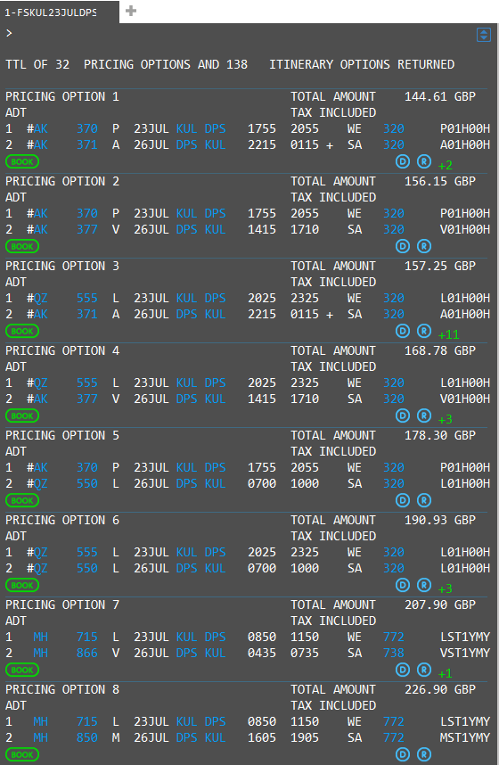 | Should you wish to book more than 1 of each type of ancillary per passenger/segment or  if You require to pay for the reservation via Agency Payment, or you wish to pay via virtual credit card, you will need to begin your booking via the availability booking flow.  This is a known issue and will be corrected in a later release  Please see separate clue card for booking from an availability booking flow.  Air Asia Malaysia (AK)  Air Asia Indonesia (QZ)  Air Asia X (D7)  Air Asia Thailand (FD)  AirAsia India (I5)  AirAsia Zest (Z2)  Thai AirAsia X (XJ)
Book required class | Click on book to select option  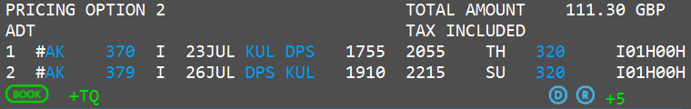
Enter mandatory passenger information  Selling ancillaries | N.TEST/JADE MRS  T.T*  W.10 HURRICANE WAY*SLOUGH*BERKS*GB*P/SL3 8AG  MT. or MF. example: MT.JADE.TEST@GALILEO.COM  SI.P1/SSRDOCSAKHK1////GB/20JAN84/F//TEST/JADE  P.LONT*02071234567  R.  To check what salutations an airline accepts – Z*NT  Launch Ancillary basket from PNR Viewer  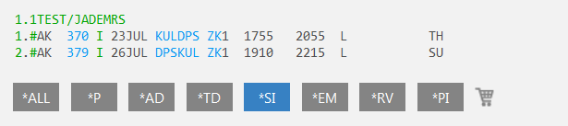  Place a quantity in corresponding white box for the ancillary that you wish to sell, remembering to select the passenger from the top left drop down box for multi passenger reservations.  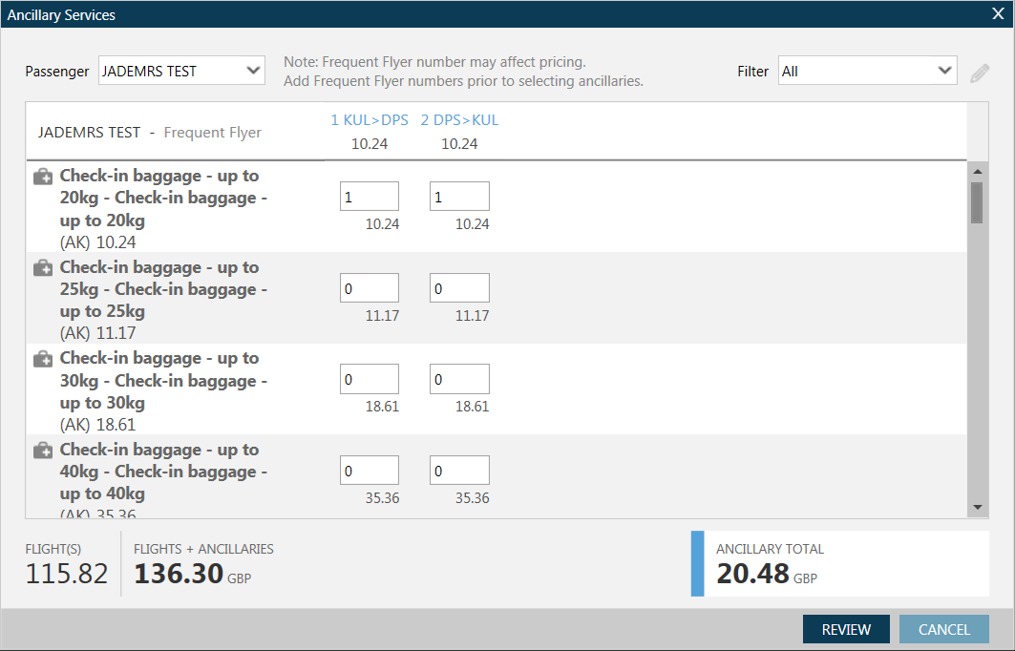  Click on review to see a summary of what ancillaries have been selected.  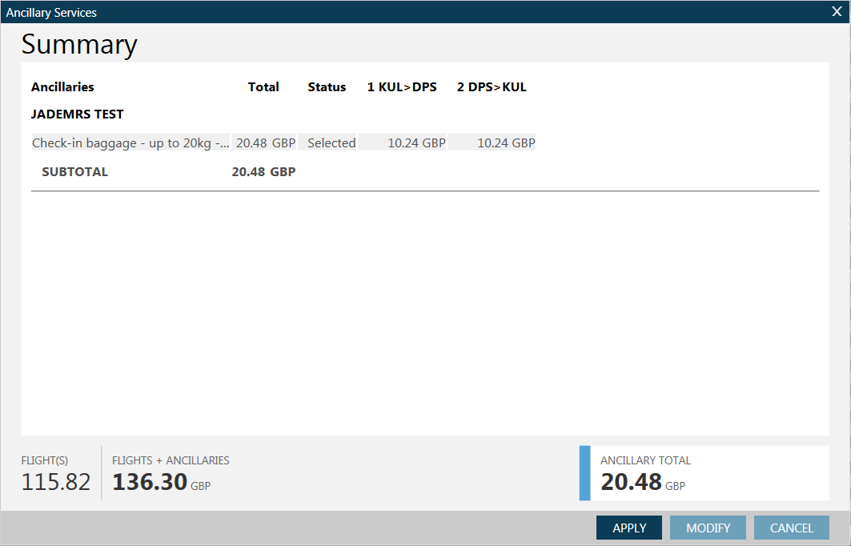 | 5 Fields required for the address including country and post code *P/  Date of birth and Nationality are required to end booking for each pax.(Use Current GDS Formats for SSRDOCS)  Ancillaries can be filtered by passenger or by ancillary type.  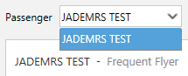  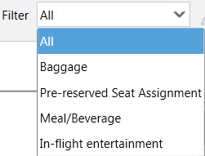  Click apply to add them to the reservation.  *Should you wish to book more than 1 of each type of ancillary per passenger/segment, you will need to begin your booking via the availability booking flow – This is a known issue and will be addressed in a future Smartpoint release*
To display seat map | Hover on the seat number for description and seat cost – click to book.  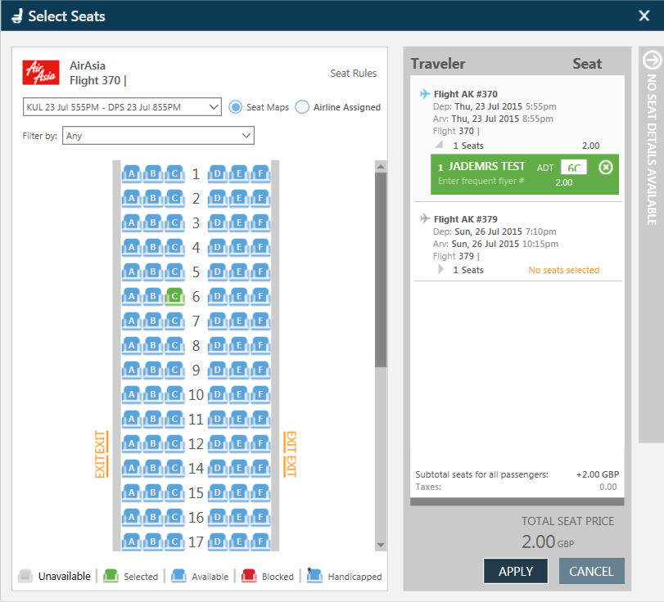 | Click on the next flight to move to that map and allocate seat number.  Total seat cost added up on the bottom right.  Apply to add to the reservation.
To Pay for and complete booking | Launch the payment screen by clicking on the # next to the flight number.  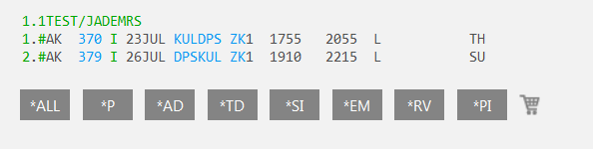  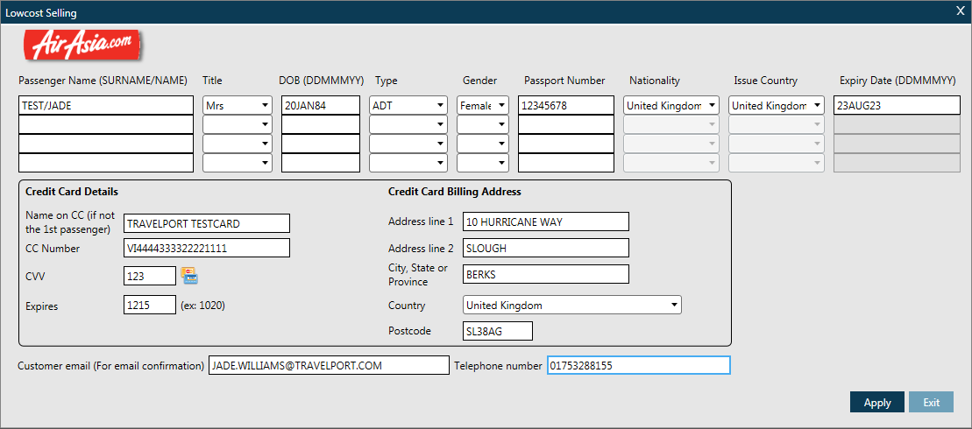  The credit card details will be added to the PNR  Now enter “ER”  An information message will spear showing updated cost inclusive of all ancillaries, fees and taxes and will ask you if you wish to continue – click yes to proceed with booking.  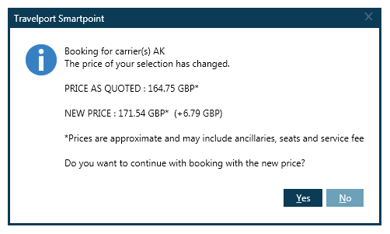  Galileo Reference returned and AirAsia vendor locator under *VL. To display the booking in the AirAsia system enter Z*R/CAK | *If you wish to pay via agency payment, you will need to start your reservation via the availability workflow*  The AirAsia confirmation will be emailed to the email address in the MT or MF field.
AirAsia Carriers currently available to book | AirAisa Malaysia (AK)  AirAsia Indonesia (QZ)  AirAsia X (D7)  AirAsia Thailand (FD)  Thai AirAsia X (XJ)  AirAsia India (I5)  Air Asia Zest (Z2)
AirAsia support the following currencies | Code Currency Name  AUD AUSTRALIAN DOLLAR  BND BRUNEI DOLLAR  CNY PRC YUAN RENMINBI  EUR EURO  GBP STERLING  HKD HONG KONG DOLLAR  IDR INDONESIAN RUPIAH  INR INDIAN RUPEE  JPY JAPANESE YEN  KRW SOUTH KOREAN WON  LKR SRI LANKAN RUPEE  MYR MALAYSIAN RINGGIT  NZD NEW ZEALAND DOLLAR  PHP PHILIPPINE PESO  SGD SINGAPORE DOLLAR  THB THAI BAHT  TWD TAIWAN NEW DOLLAR  USD US DOLLAR

For further information please see ASK Travelport, Travelport Aggregated Shopping User Guide, Answer ID AN9274

